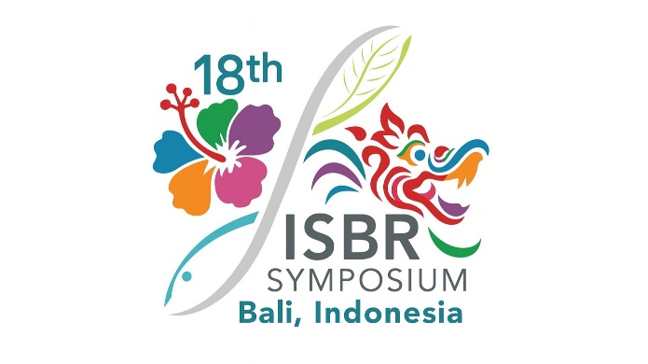

PROPOSAL SUBMISSION TEMPLATE
TOPIC-SPECIFIC PARALLEL SESSION

Parties interested in organizing a topic-specific parallel session (TSPS) at ISBR2027 should complete and submit this application form. Parallel sessions will be 1.5 hours long, with five (5) speakers, each giving a 15-minute presentation.
Instructions
- Download and complete this template, then submit it by email to admin@isbr.info with the subject line "TSPS PROPOSAL"
- Proposals are due November 15th, 2026.

Proposed title for topic-specific parallel session
Name, email address, and affiliation of organizer(s)
Abstract describing the session topic and its relevance to the ISBR2027 theme (max 300 words)
Proposed session chair
Proposed speakers and presentation titles/content
Introduction (5 min)
Speaker 1 (15 min)
Speaker 2 (15 min)
Speaker 3 (15 min)
Speaker 4 (15 min)
Speaker 5 (15 min)
Discussion & wrap up
(10 min)
Please acknowledge the following
Do you agree to strive for diversity (gender, race, nationality, etc.) across the speakers in your session? |  | Yes | No
Do you acknowledge that there is no funding to support the registration, travel, or accommodation for the session chair and/or the speakers in your session? |  | Yes | No

